**Lab 3**

Q1:   


Q2:  
a. press j  
b. press k

c. in command mode, type /age and press Enter. To find the next occurrence, press n

d. In command mode, type 5G.

e. while on the line you want to delete, type dd to delete the current line. Then, type 5dd to delete line 5.

f. while in command mode, press A. This moves the cursor to the end of the line and enters insert mode, allowing you to start typing at the end of the line.

Q3:

Q4:

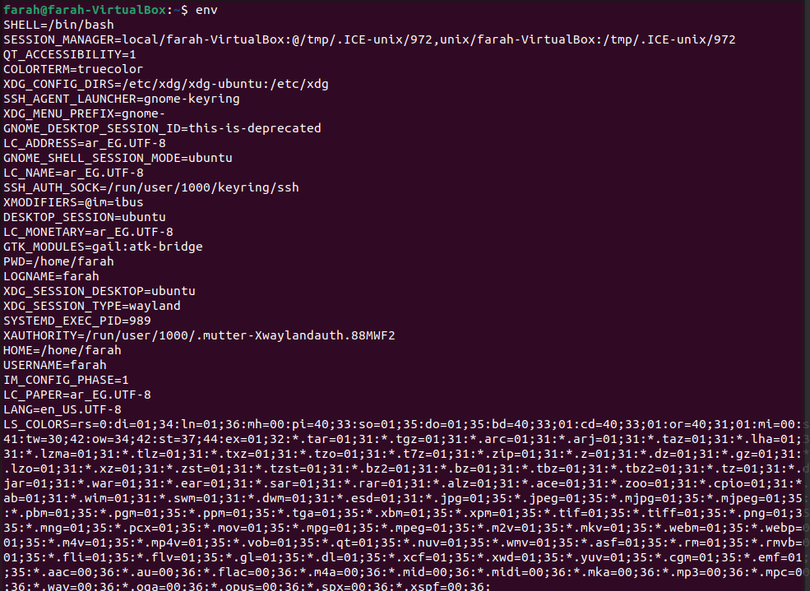

Q5:

Q6:





Q7:

Q8:  
1- For sh (Bourne Shell):

The main initialization file is /etc/profile.

Additionally, individual users can have a per-user initialization file, typically ~/.profile.

2- For ksh (Korn Shell):

The main initialization file is /etc/profile.

Users may also have a per-user initialization file, typically ~/.profile.

3- For bash (Bourne Again Shell):

The main initialization files are:

/etc/profile (system-wide).

/etc/bash.bashrc (system-wide).

Additionally, individual users can have per-user initialization files:

~/.bash_profile

~/.bashrc

~/.bash_login

Q9:  


Q10:

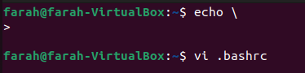

The backslash (\) is used as an escape character. In this context, the backslash is escaping the newline character, essentially telling the shell to treat the newline as part of the same command. Therefore, when you press Enter, you will notice that the shell continues the command on the next line.

The > prompt that appears indicates that the shell is expecting more input to complete the command. It means that the command is not yet complete, and you can continue typing to finish it.  
  
Q11:  
